Online mediator training course
Course Dates tbc August September 2020
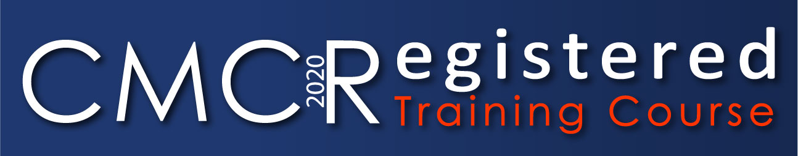
Civil and Commercial - Mediation Training
Mediation helps to resolve conflicts in the workplace, between businesses, and between businesses and consumers.
The Courts are increasingly encouraging parties to mediate. With such a huge variety of disputes which can be resolved through mediation, the civil/commercial market is growing all the time.
Pro Mediate a CMC Registered mediation provider, provides the best value Civil Mediation Council registered mediation training courses to enable you to become an accredited mediator.
A requirement is to attend one day in person which will be arranged to suit the students enrolling on the course.
Why ProMediate?
• CMC Registered Mediation Provider and Training Provider
• Business orientated, allowing completion of the course online save for one assessment day in person
• Competitively priced compared to other training providers at £1000 plus VAT
• Mediation business session included with advice on starting a mediation business or incorporating mediation into your work or profession
• Training includes online mediation and telephone mediation training, which are growth areas
• Membership of the ProMediate panel of mediators following completion of observations
• Prioritisation on ProMediate Observations
• Mentoring on an ongoing basis and ProMediate runs a mediator diversity programme
• Training from mediators who run the HMCTS Manchester Mediation Pilot, an ADR provider which is certified by CTSI to deal with Consumer disputes and is at the cutting edge of mediation in the UK.
• Course director is experienced mediator, Council Member of the Law Society, solicitor, barrister and fee paid judge.
The Course
Delegates are trained by practicing mediation practitioners who are not solely trainers, having a real understanding of mediation as a business.
Being accredited training, students upon completion of the course are entitled to apply to join the Civil Mediation Council as Registered mediators, having completed the requisite shadowing.
Accredited Training
This accredited training will be of particular interest to businesses, litigation lawyers and HR professionals who wish to become civil and commercial mediators.
ProMediate’s mediator training course has a business emphasis and is specifically designed for your business needs.
ProMediate (UK) Limited is a member of the Civil Mediation Council and Registered CMC Mediation Provider, being one of very few Providers to offer Training too.
What are the benefits?
Once you successfully complete your five-day course you will be entitled to membership of our panel, to register with the Civil Mediation Council subject to completing your 3 observations and complying with the CMC’s requirements. – Applying for Registered Status
With such a huge variety of disputes which can be resolved through mediation, the mediation market is growing all the time.
Feedback

“You are very good at all the technology”
“Course is very good. You are a great teacher”
”thank you so much. It was brilliant!”y
”awesome day today I really enjoyed it!”

Contact Us
Pro Mediate
enquiries@promediate.co.uk
Visit us on the Web: www.promediate.co.uk

